EXPERIMENT NO – 9

1. **Install ARP Watch**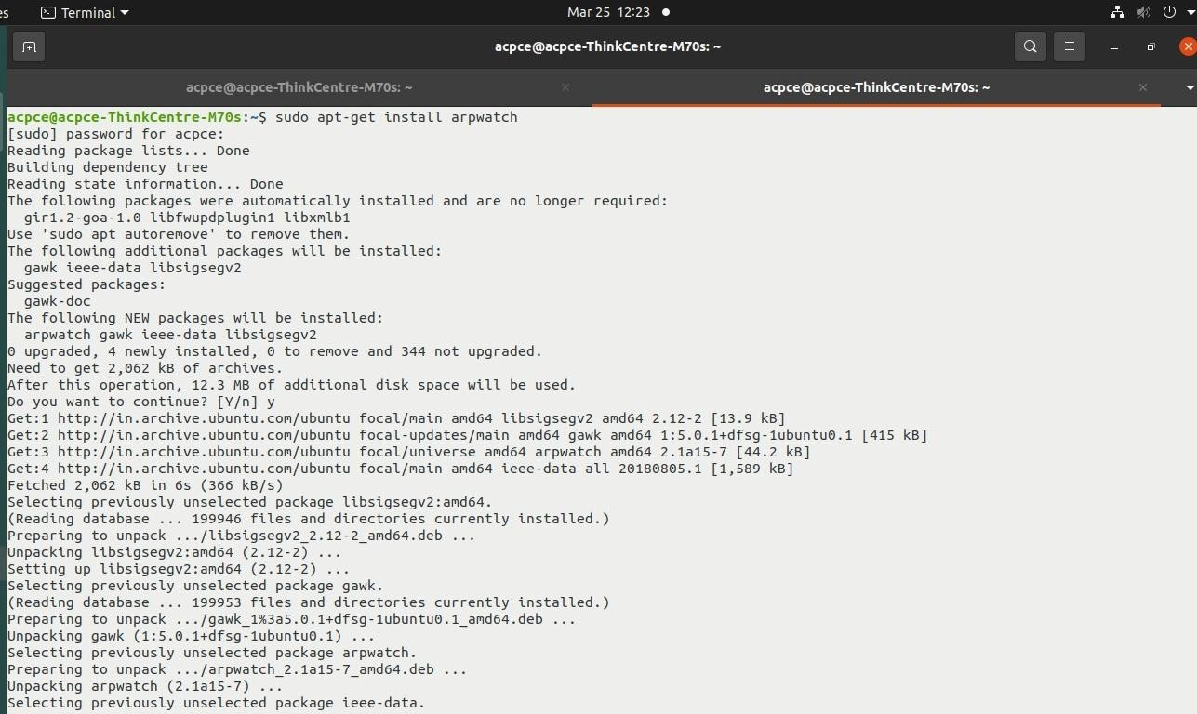
2. **Use Nmap to gather detailed network information**



1. **ARP Spoofing Detection with Nmap**

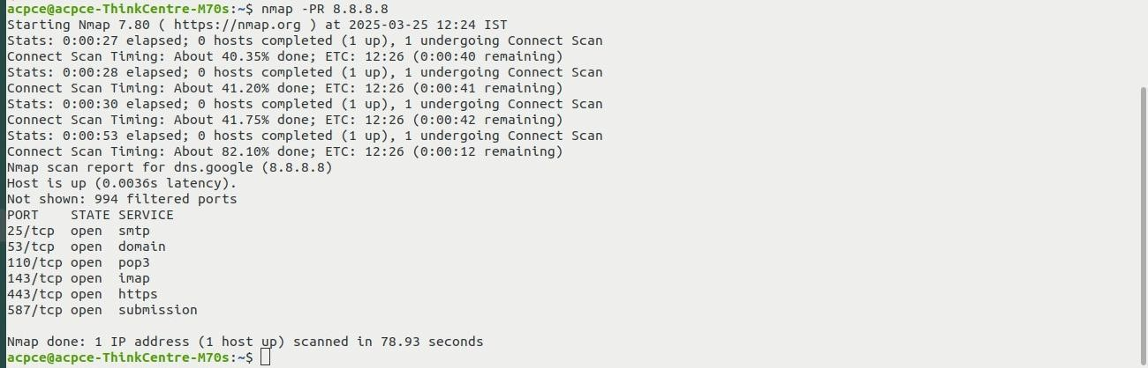

1. **OS Fingerprinting using Nmap**

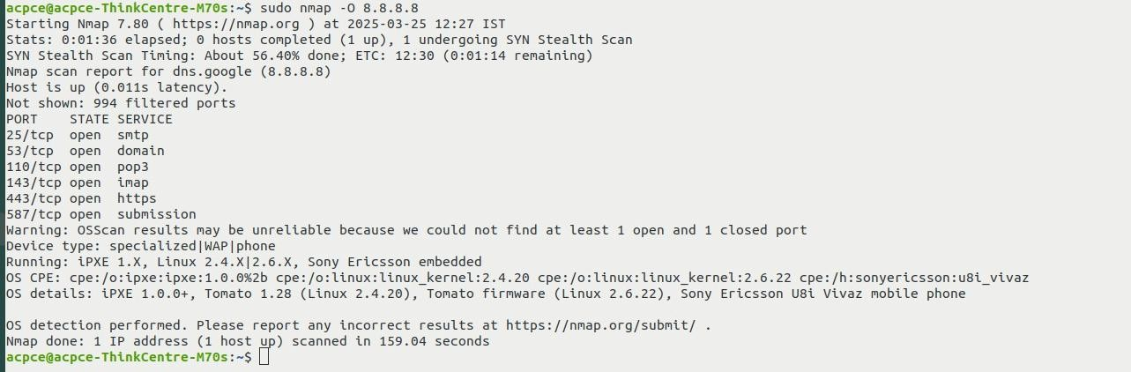

1. **ARP spoofing using wireshark**

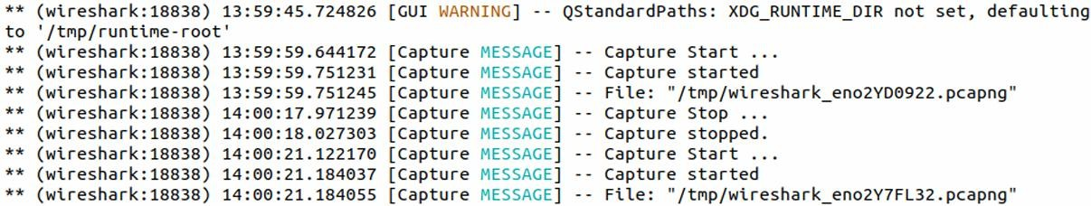

1. **Simulate the DoS Attack Using Hping3**

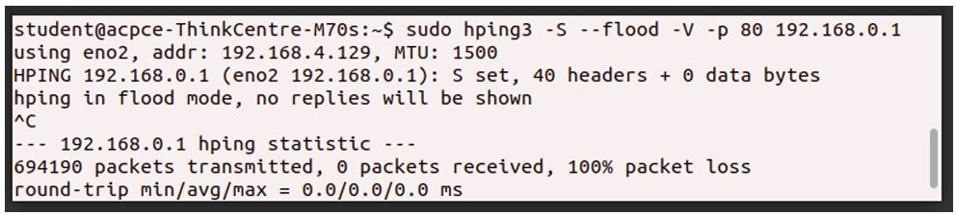

1. **Display in Wireshark**

